Joao Vitor Bonanoni

Computer Application

Sayed Shah

Nov 11 2020

**Microsoft Access Assignment #4**

Introduction:

This is a project for the computer application class about the step by step of a database creation and queries.

It was used the Microsoft Access application, Turnitin and GitHub platform.

During the process there were some difficulties with Access application, however after some YouTube videos I could understand.

Methodology:

This project started with the creation of two tables about students records. After that I created five queries to help the access of the database. The queries were based on GPA, year in the college, and country.

Results:

This project could improve my knowledge about Microsoft Access and GitHub applications.

Conclusion: the database was really good presented and complete. With a good organizations and good queries.

Future work:

I intend to use more this application in my major.

First table with: Student ID, First and Last name, Country, and Phone number.

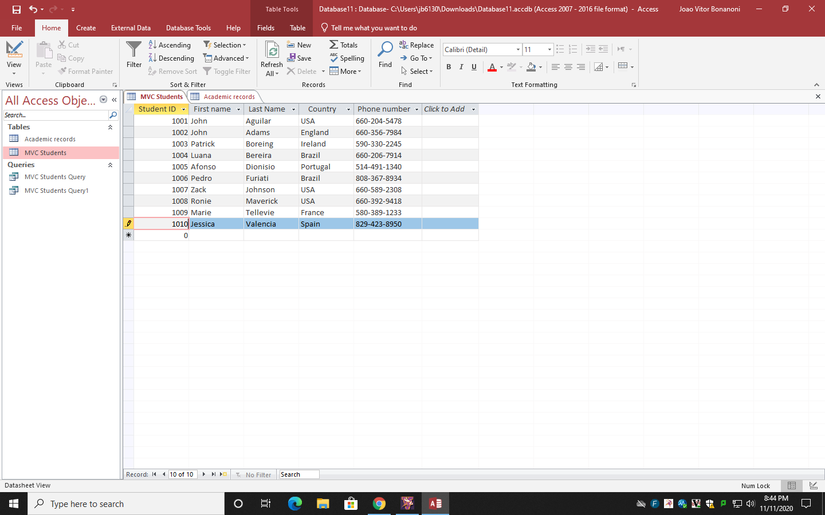

View mode

Design mode

Add Fields

Second table with: Student ID, GPA, and Year in college.

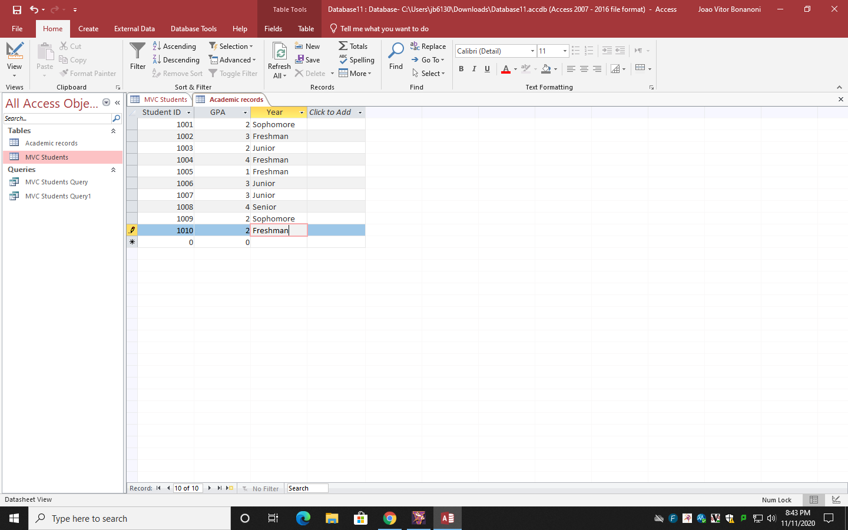

Query: GPA<3

Design mode and View mode

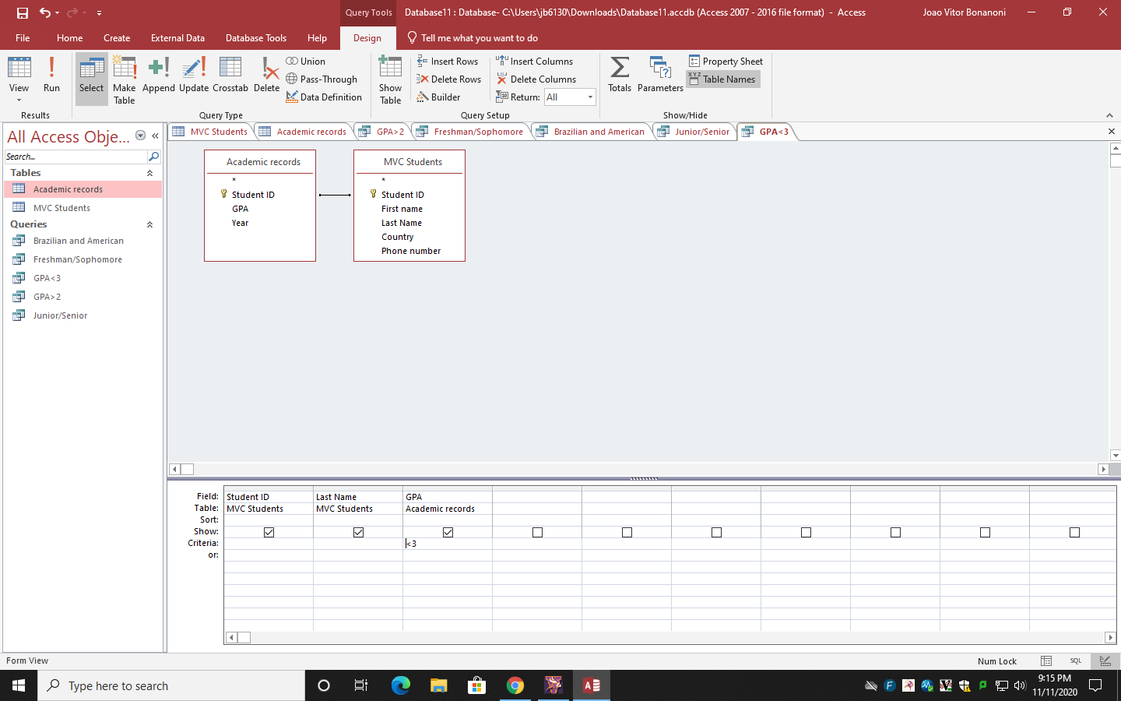

Connection of fields

